Question 1:
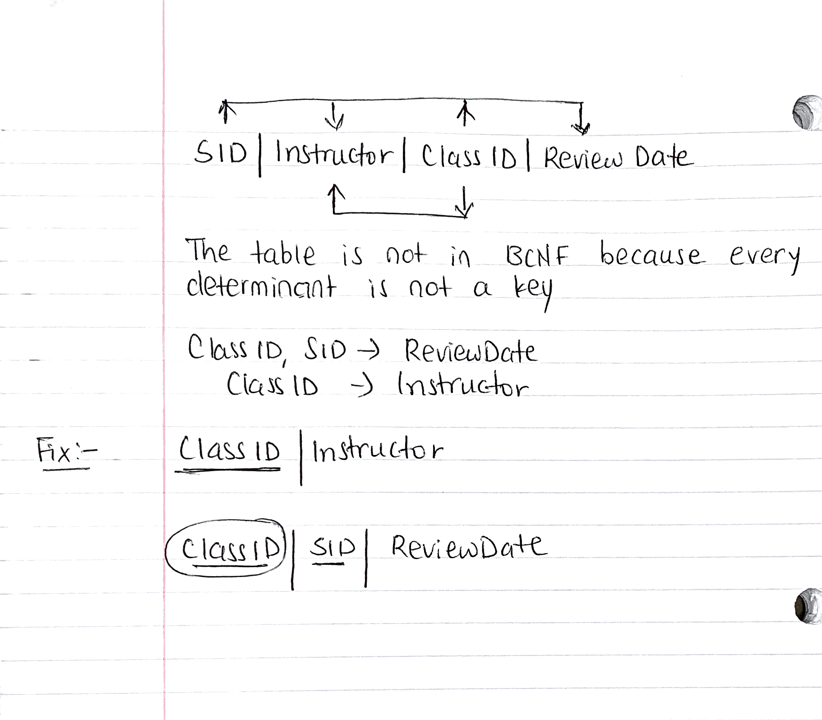

Question 2:-
SELECT empno,ename, mgr
from emp
where sal > '200';

insert into dept (deptno, dname, loc)
values (50, 'Marketing', 'Chicago');

update emp
set comm = 100
where comm = 0;

update emp
set comm = 100
where comm is null;

delete from emp
where hiredate < '01-Jan-1979';

